Changes to website

1. Critical: Pricing Logic & Route Calibration

This is the highest priority area as the current system is significantly under-quoting specific routes.
- Durban Shared Load "Floor" Price: The system is currently quoting JHB/DBN shared loads as low as R 1,400. This must be corrected. We need a minimum floor rate for this route of between R 4,500.00 and R 5,500.00. •
- We have although attached a new costing sheet with new rates

- System Discrepancy (Cloud vs. Web App): There is a large gap between the manual Web Cloud totals and the Web App totals for the same inventory (e.g., R 14,800 on Cloud vs R 10,400 on the App). • (Source: Wendy, Dima)
- Cube Rate Discrepancy: The manual logic uses R 13.00/cube, but the app appears to be calculating at R 6.00/cube on certain routes. We need these aligned.
- We have although attached a new costing sheet with new rates
- Inter-Provincial Floor Rates: We need a general "minimum floor" adjustment for all long-distance moves to ensure small volume loads remain profitable

2. UI/UX & Frontend Improvements
- "Add Item" Button Visibility: The button to add items/rooms is too small and difficult for users to find. It needs to be much more prominent. • (Source: Atu, Lorraine, Dima)
- Floor & Access Details: We need to go beyond "1st Floor." Please add options for "Double Volume" and "Multiple Flights of Stairs" to accurately capture labor. •

- Loading State UX: To improve the wait-time experience while the quote generates, can we add brand-related lifestyle photos or high-quality background images? • (Source: Dima)
- Branding Consistency: Please integrate the official company logo into the app interface to match our professional PDF outputs. • (Source: Wendy)
- Packing & Box Logic: The "Deliver Boxes" tab is appearing inconsistently (potential bug), and the Linen Box pricing needs to be standardized. ]

3. Inventory & Database Updates
- Volume Pull-Through Bug: Item volumes are not consistently populating. Selecting an item should automatically pull the preset volume and price every time. • (Source: Lorraine, Mathildah)
- Inventory Master List: Please add "Pedestals" to the Bedroom category. For all other missing items and updated volumes, please refer to the attached Excel file from Atu. This should be the single source of truth for the database update. • (Source: Wendy, Atu)
4. New Feature Requests
- Special Wrapping Field: We need a toggle or note field for "Special Wrapping" on individual items with a manual fee input (e.g., R 600.00). • (Source: Wendy)
Hi Ray,

Please see below notes made by Jose

1. The notes need to be after the client has filled in the inventory. And the “I am old school” needs to be on the inventory page for when the client feels this is something that they are not able to do.

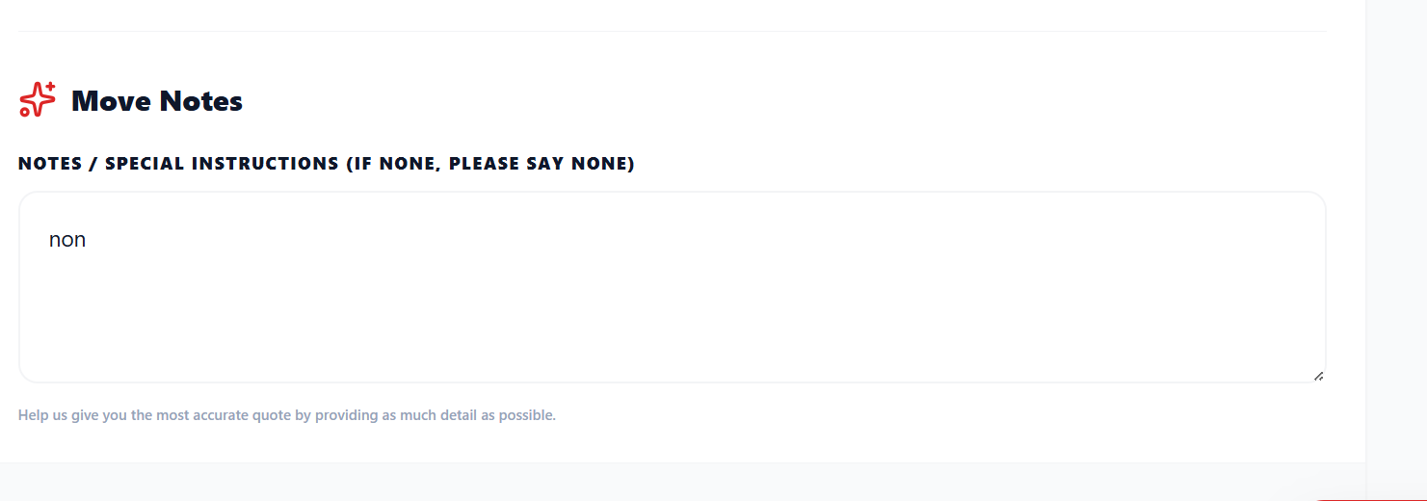
2. Boxes prices Linen is R165 per box

3. Special handling items should not be the first room that the client sees. It needs to be at the end.

Inventory full list ( please dont remove any currently on the app but all any we dont have make sure we have all on this image)

PDf with list CamScanner 2026-01-30 10.48
Excell sheet Additional items to rooms with volumes

Notes where made by our team, with regards to costings please keep their notes in mind to see if there are any calc issues but we are now working off new costings

NB Sheet with new costings in folder WORKINGS FOR CURT APP PRICING.xlsx 20-05-2026.xlsx

